ECA5802-IOE AND AI DRIVEN SYSTEMS
EXPERIMENT 4: SIMULATION AND COMPARATIVE PERFORMANCE EVALUATION OF ZIGBEE,6LOWPAN AND NB-IOT COMMUNICATION PROTOCOLS FOR IOE APPLICATIONS

OBJECTIVES:
- To simulate Zigbee, 6LoWPAN, and NB-IoT communication protocols for IoE applications.
- To compare the protocols based on throughput, latency, reliability, and energy consumption.
- To identify the most suitable communication protocol for different IoE applications.

PROGRAM CODE:
import numpy as np
import matplotlib.pyplot as plt
from scipy.special import erfc
distance = np.linspace(10, 1000, 100)
# =====================================================
# Common BER equation
# BER = 0.5 * erfc(sqrt(SNR))
# =====================================================
# =====================================================
# 1. ZIGBEE
# =====================================================
Pt = 0 # Transmit power (dBm)
PL0 = 40 # Path loss at 1 m (dB)
n = 3.0 # Path loss exponent
N = -120 # Noise power (dBm)
PL = PL0 + 10*n*np.log10(distance)
Pr = Pt - PL
SNR = Pr - N
BER = 0.5 * erfc(np.sqrt(10**(SNR/10)))
plt.figure(figsize=(7,5))
plt.semilogy(distance, BER)
plt.xlabel("Distance (m)")
plt.ylabel("Bit Error Rate (BER)")
plt.title("Zigbee: BER vs Distance")
plt.grid(True)
plt.show()
# =====================================================
# 2. 6LoWPAN
# =====================================================
Pt = 0
PL0 = 40
n = 3.0
N = -120
PL = PL0 + 10*n*np.log10(distance)
Pr = Pt - PL
SNR = Pr - N
BER = 0.5 * erfc(np.sqrt(10**(SNR/10)))
plt.figure(figsize=(7,5))
plt.semilogy(distance, BER)
plt.xlabel("Distance (m)")
plt.ylabel("Bit Error Rate (BER)")
plt.title("6LoWPAN: BER vs Distance")
plt.grid(True)
plt.show()
# =====================================================
# 3. NB-IoT
# =====================================================
Pt = 23
PL0 = 31
n = 3.5
N = -120
PL = PL0 + 10*n*np.log10(distance)
Pr = Pt - PL
SNR = Pr - N
BER = 0.5 * erfc(np.sqrt(10**(SNR/10)))
plt.figure(figsize=(7,5))
plt.semilogy(distance, BER)
plt.xlabel("Distance (m)")
plt.ylabel("Bit Error Rate (BER)")
plt.title("NB-IoT: BER vs Distance")
plt.grid(True)
plt.show()

OUTPUT GRAPH:
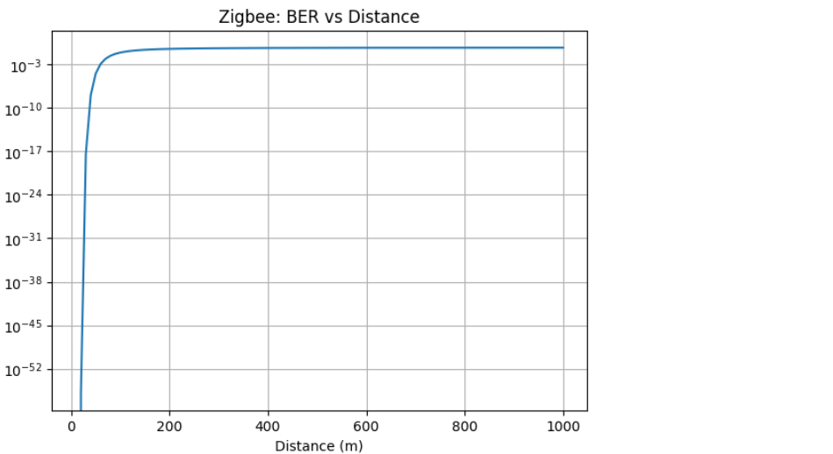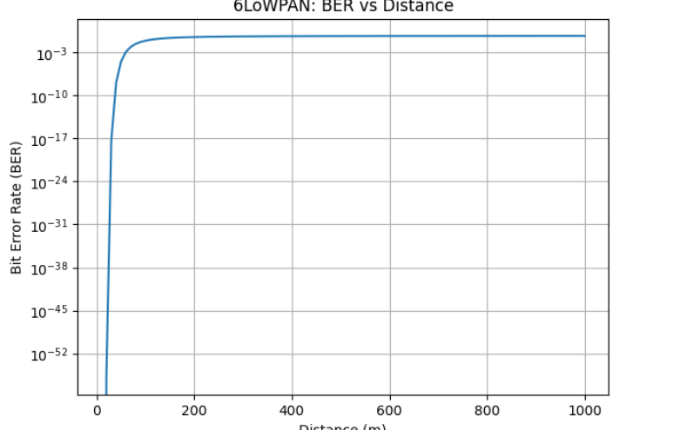
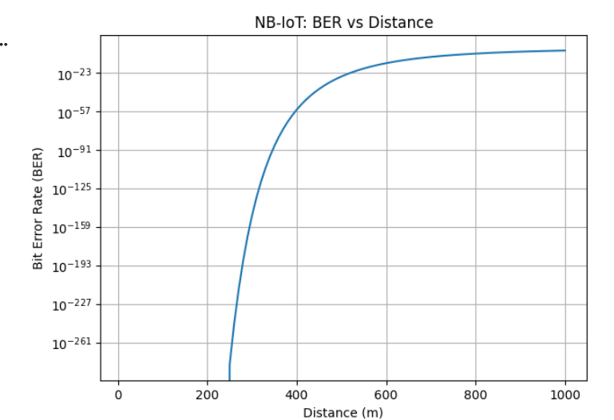

TABLE COLUMN:
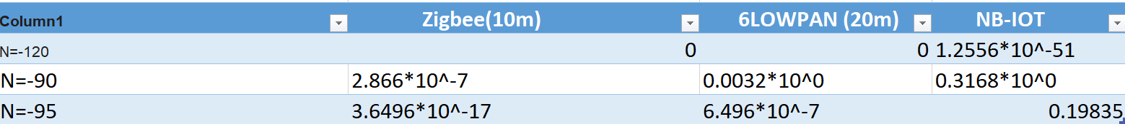

RESULT:
The Zigbee, 6LoWPAN, and NB-IoT communication protocols were studied and compared based on their performance parameters. Their advantages and limitations were analyzed for different IoE applications. Thus, a suitable communication protocol can be selected based on application requirements.

